**LAB- 8(program)**

**PROGRAM 8 :- STUDENT ENROLLMENT DATABASE**

**Consider the following database of student enrollment in courses and books adopted for each course.**

**STUDENT (regno: String, name: String, major: String, bdate: date)**

**COURSE (course #: int, cname: String, dept: String)**

**ENROLL (regno: String, cname: String, sem: int, marks: int)**

**BOOK_ADOPTION (course #: int, sem: int, book-ISBN: int)**

**TEXT(book-ISBN:int, book-title:String, publisher:String, author:String)**

**i. Create the above tables by properly specifying the primary keys and the foreign keys.**

**ii. Enter at least five tuples for each relation.**

**iii. Demonstrate how you add a new text book to the database and make this book be adopted by some**

**department.**

**iv. Produce a list of text books (include Course #, Book-ISBN, Book-title) in the alphabetical order for courses**

**offered by the ‘CS’ department that use more than two books.**

**v. List any department that has all its adopted books published by a specific publisher.**

**Create table:-**

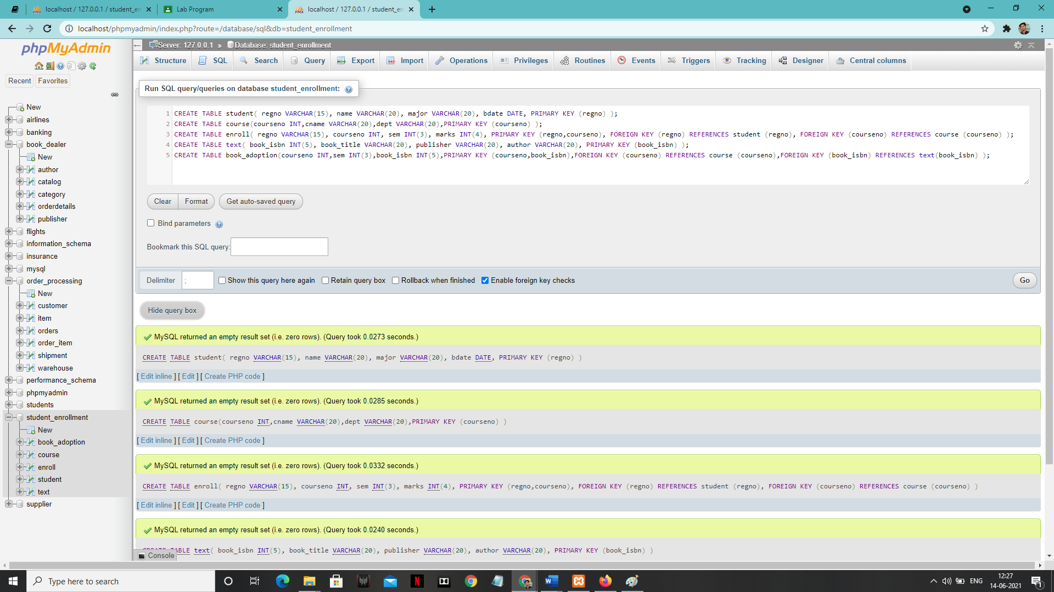

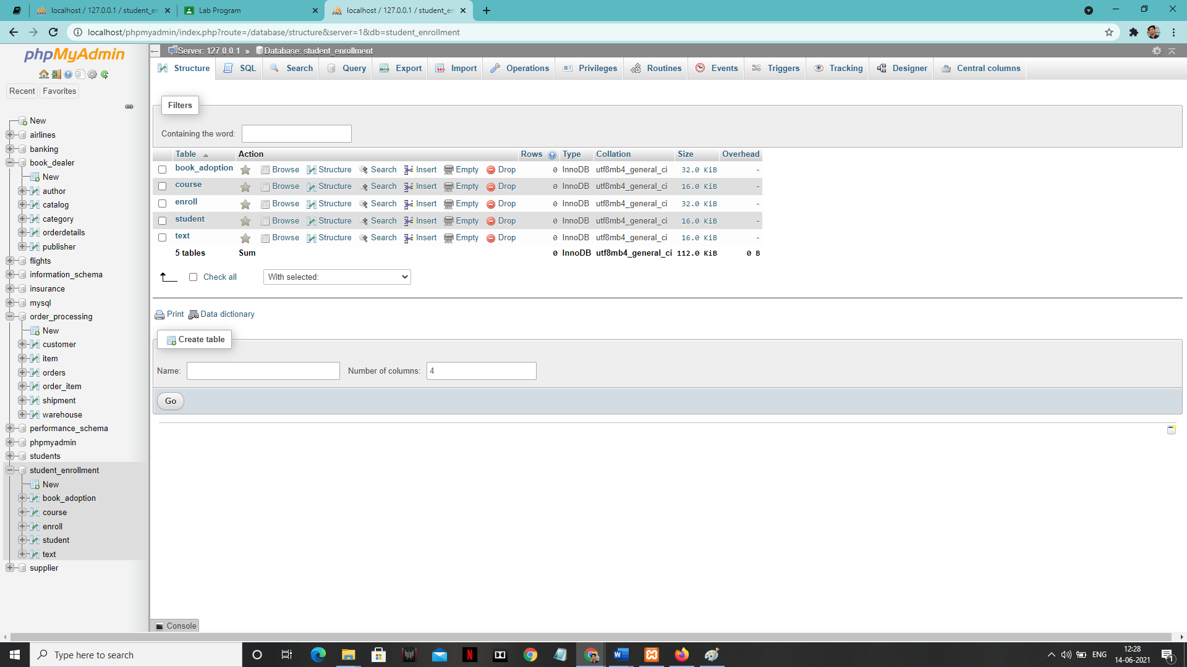

1. **Enter tuples for each relation.**

**‘STUDENT’ table:**

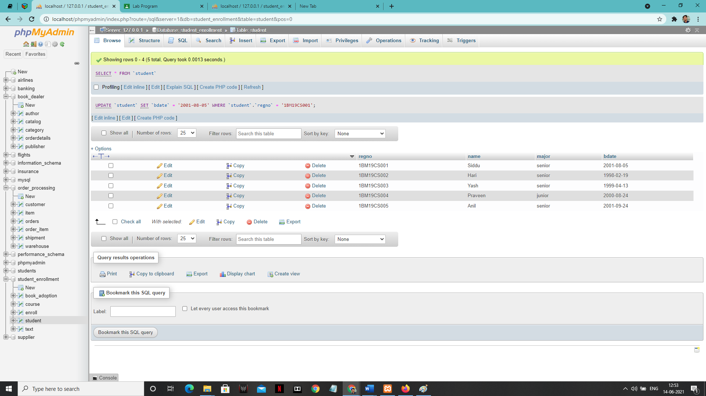

**‘COURSE’ table:**

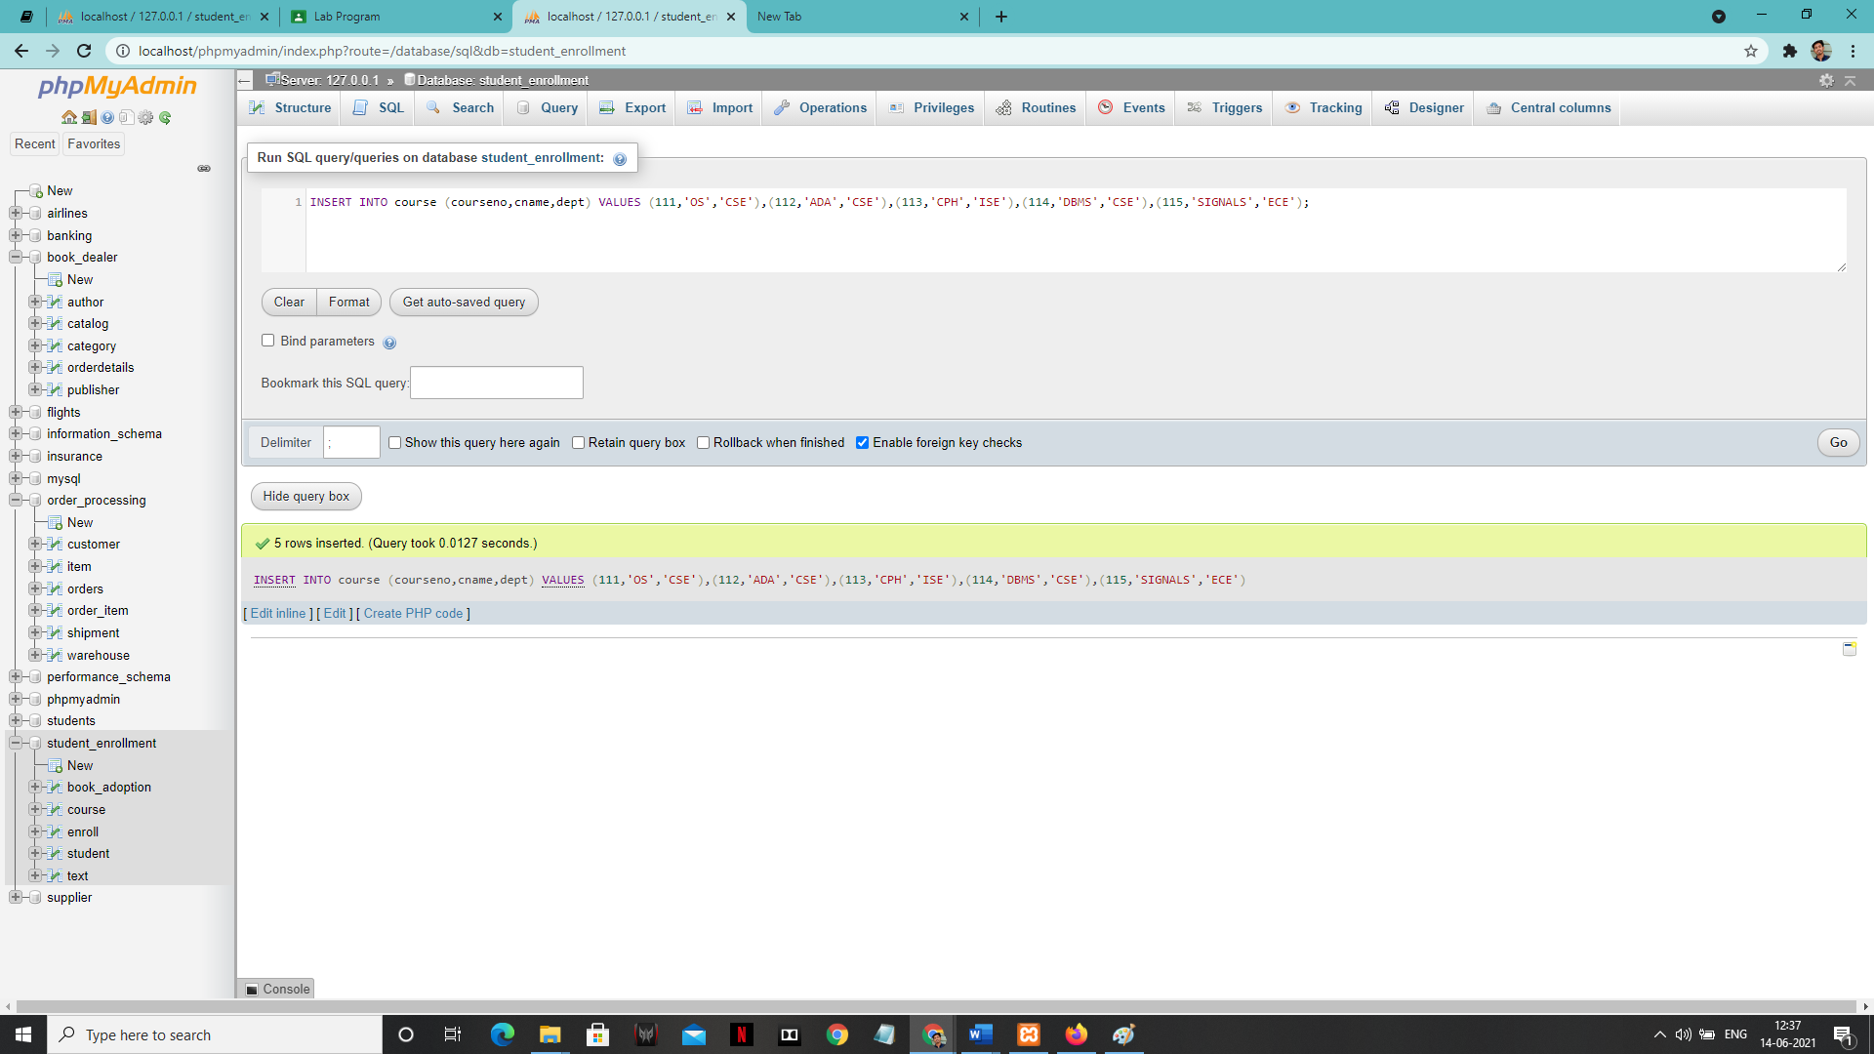

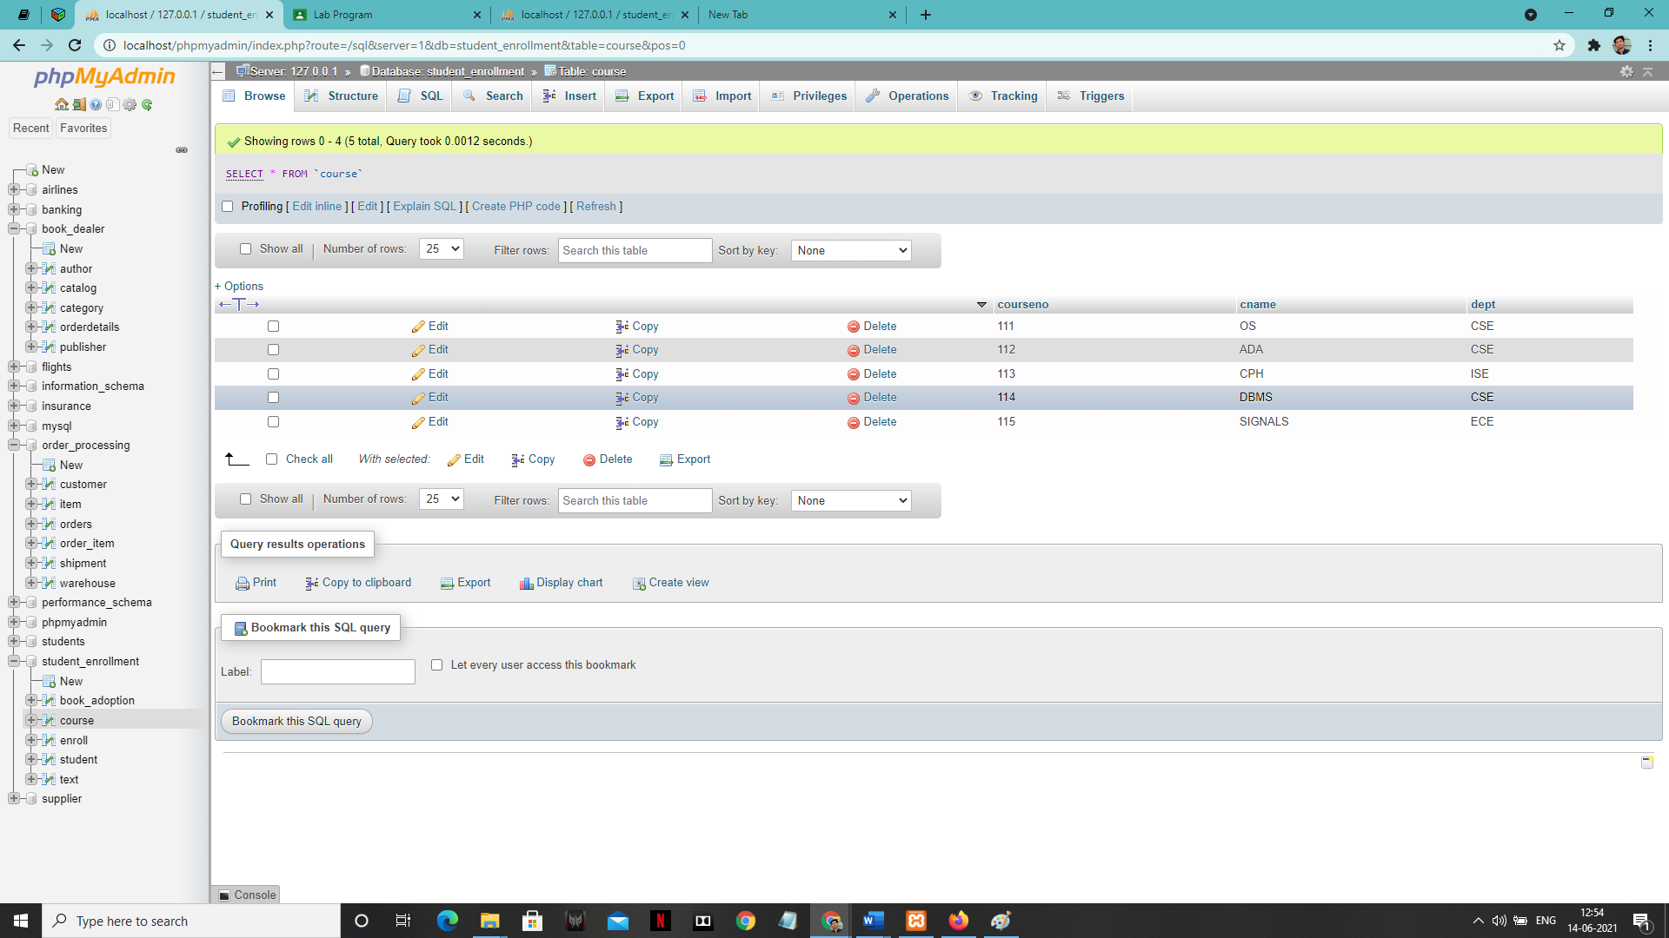

**‘ENROLL’ table:**

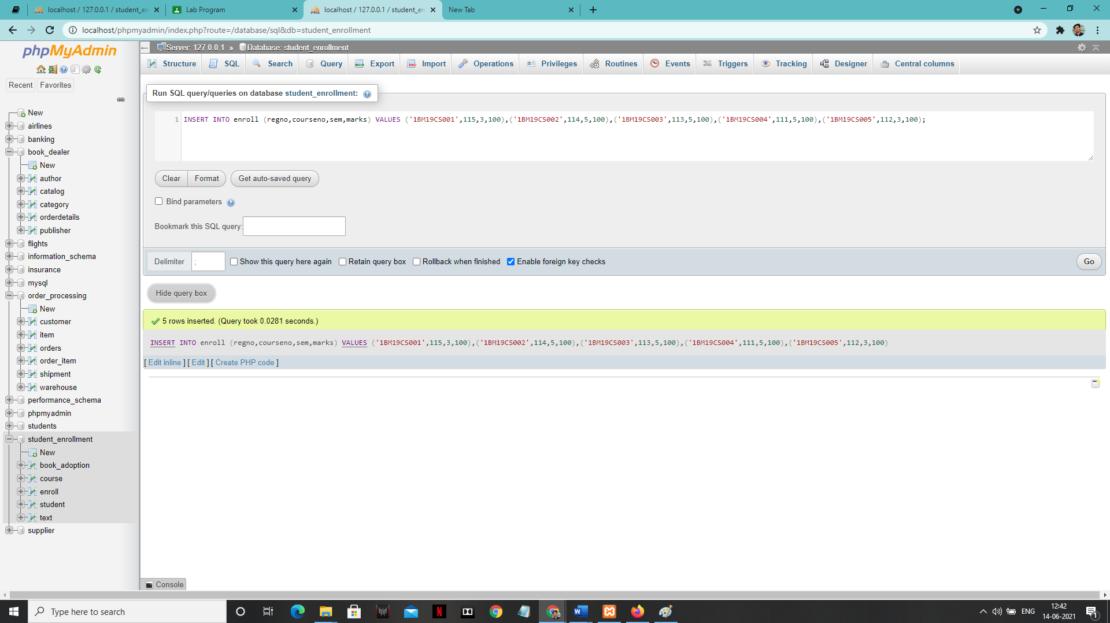

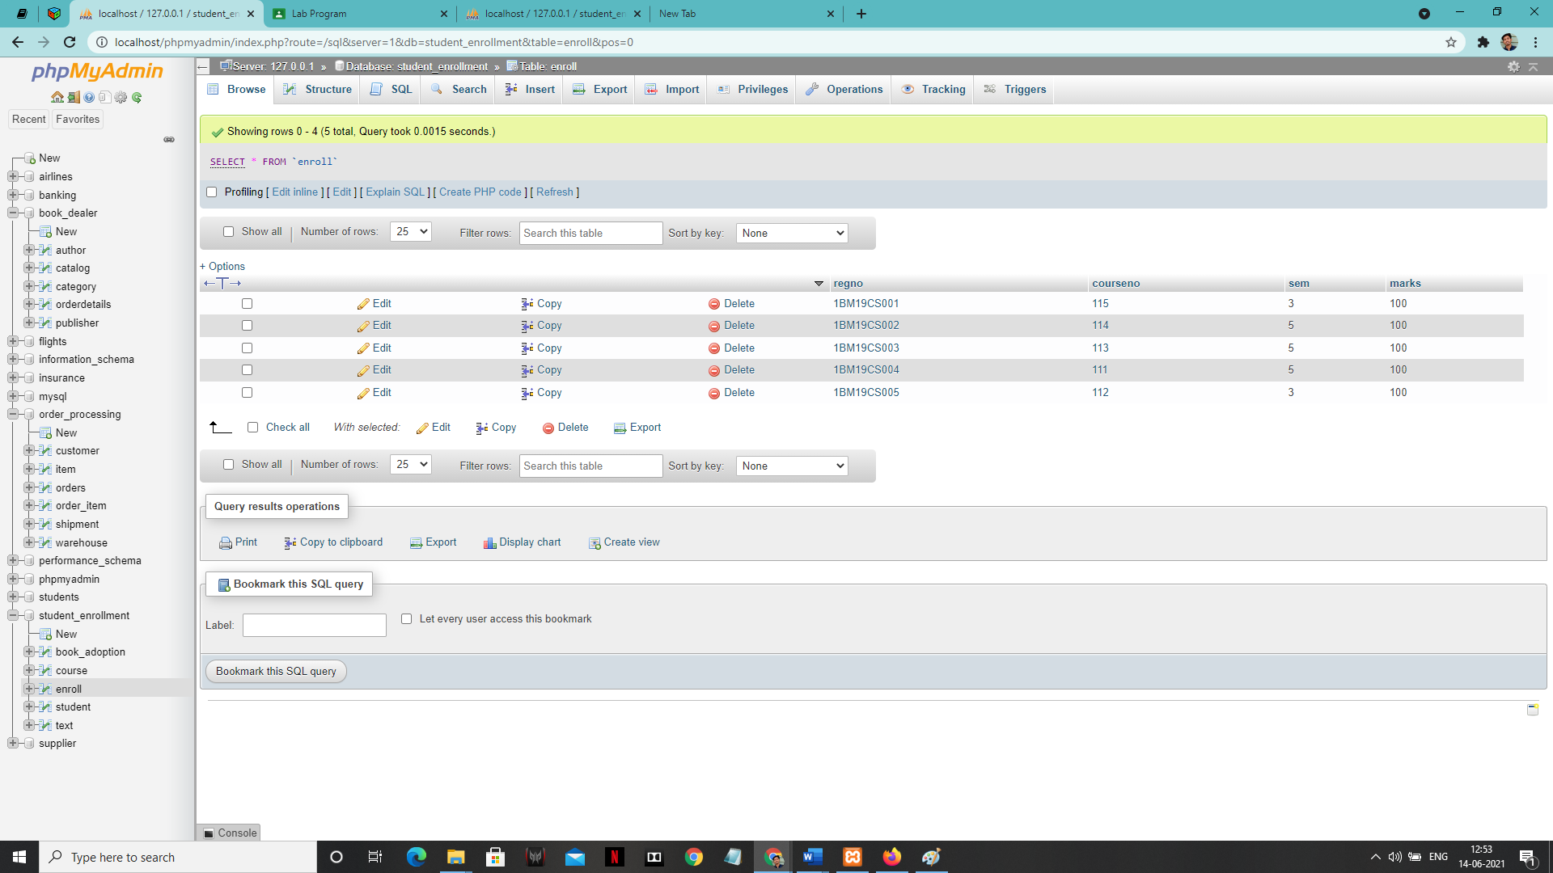

**‘BOOK ADOPTION’ value: -**

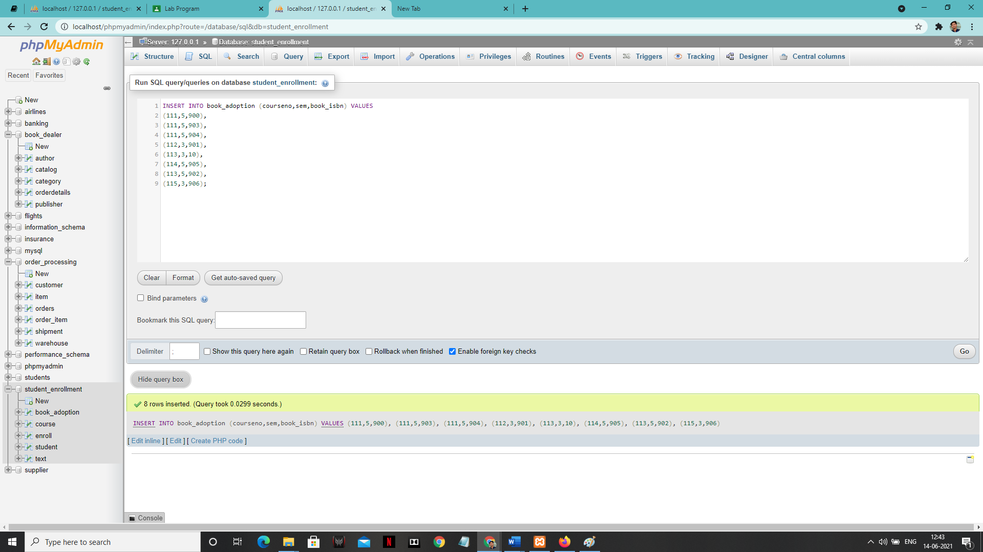

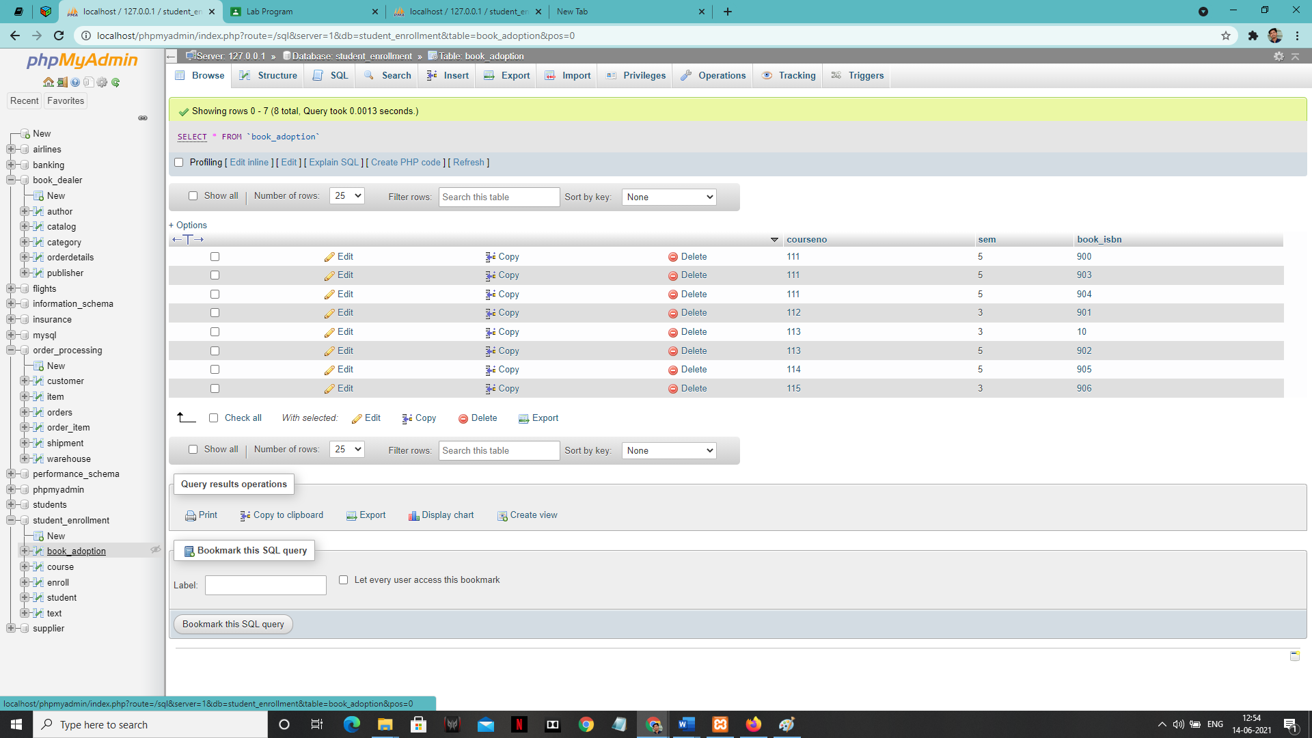

**‘TEXT’ table:**

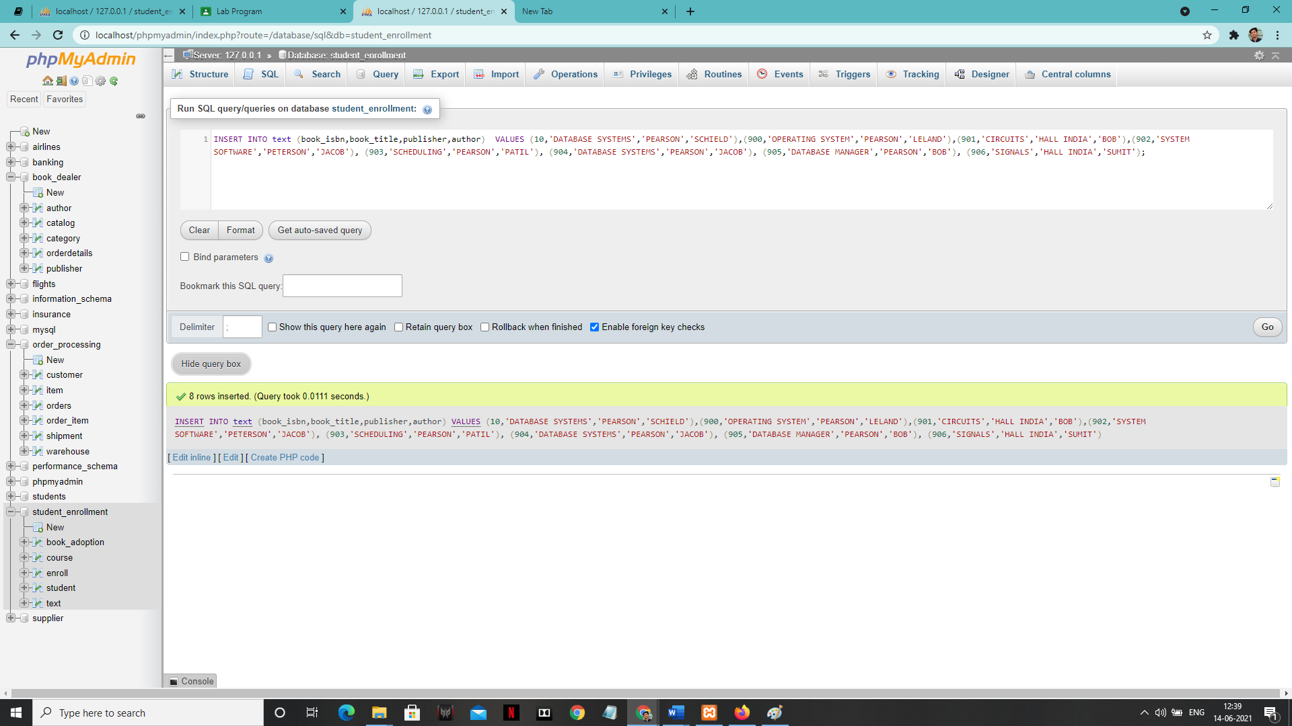

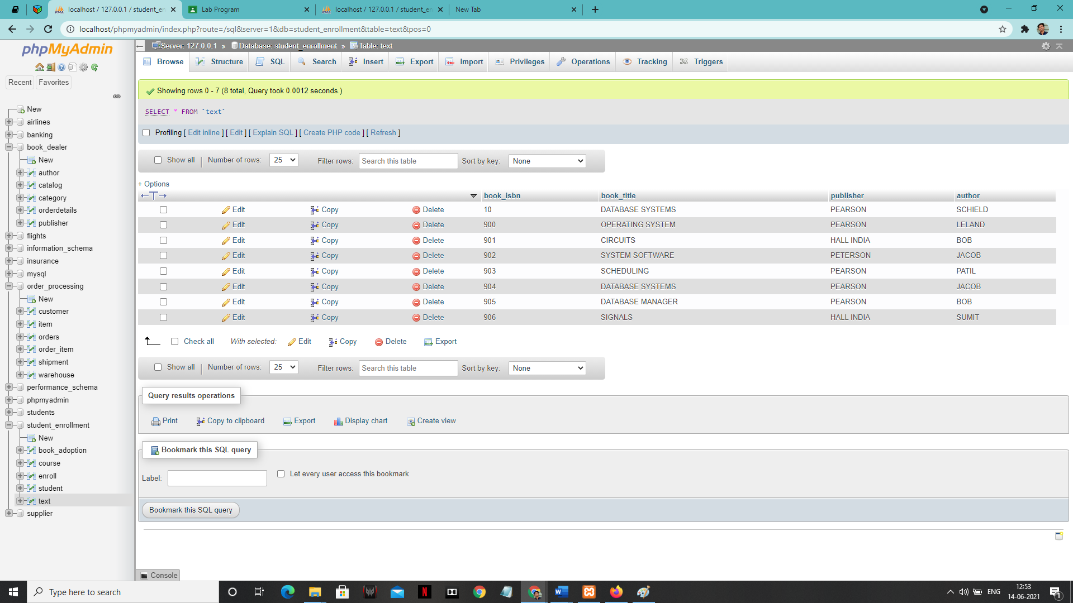

**SOLUTION**

**1:-**

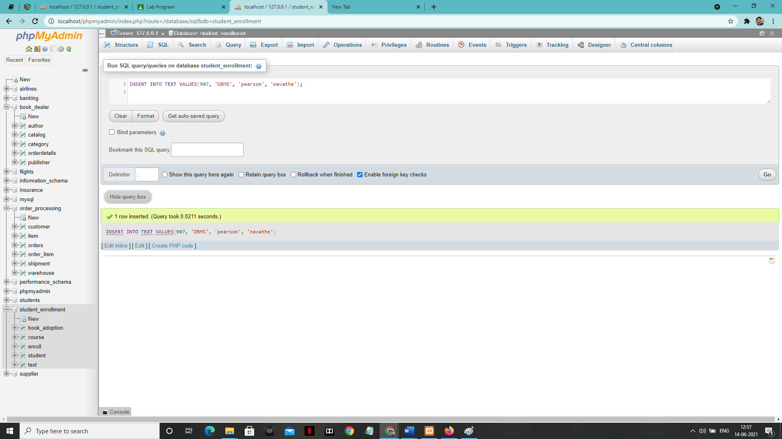

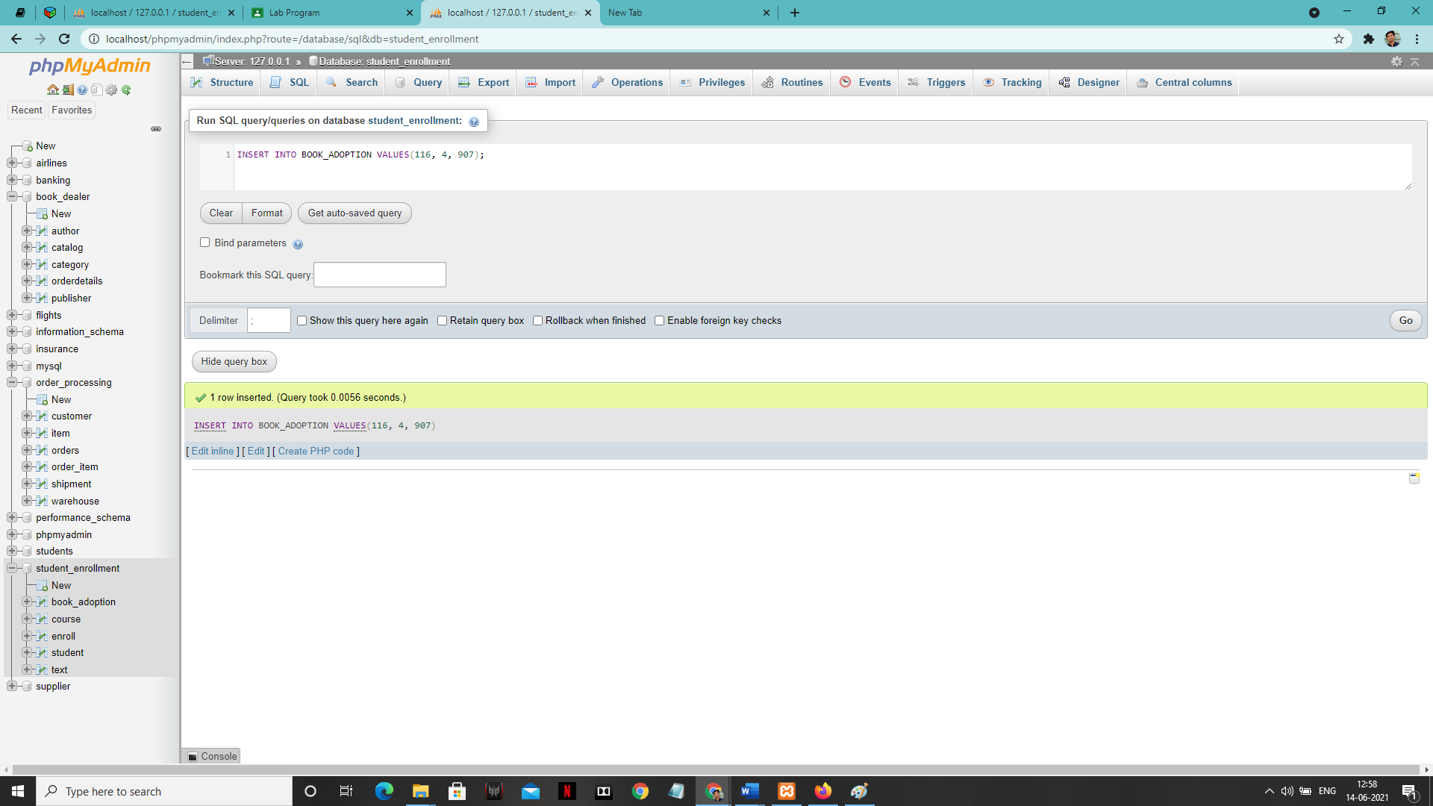

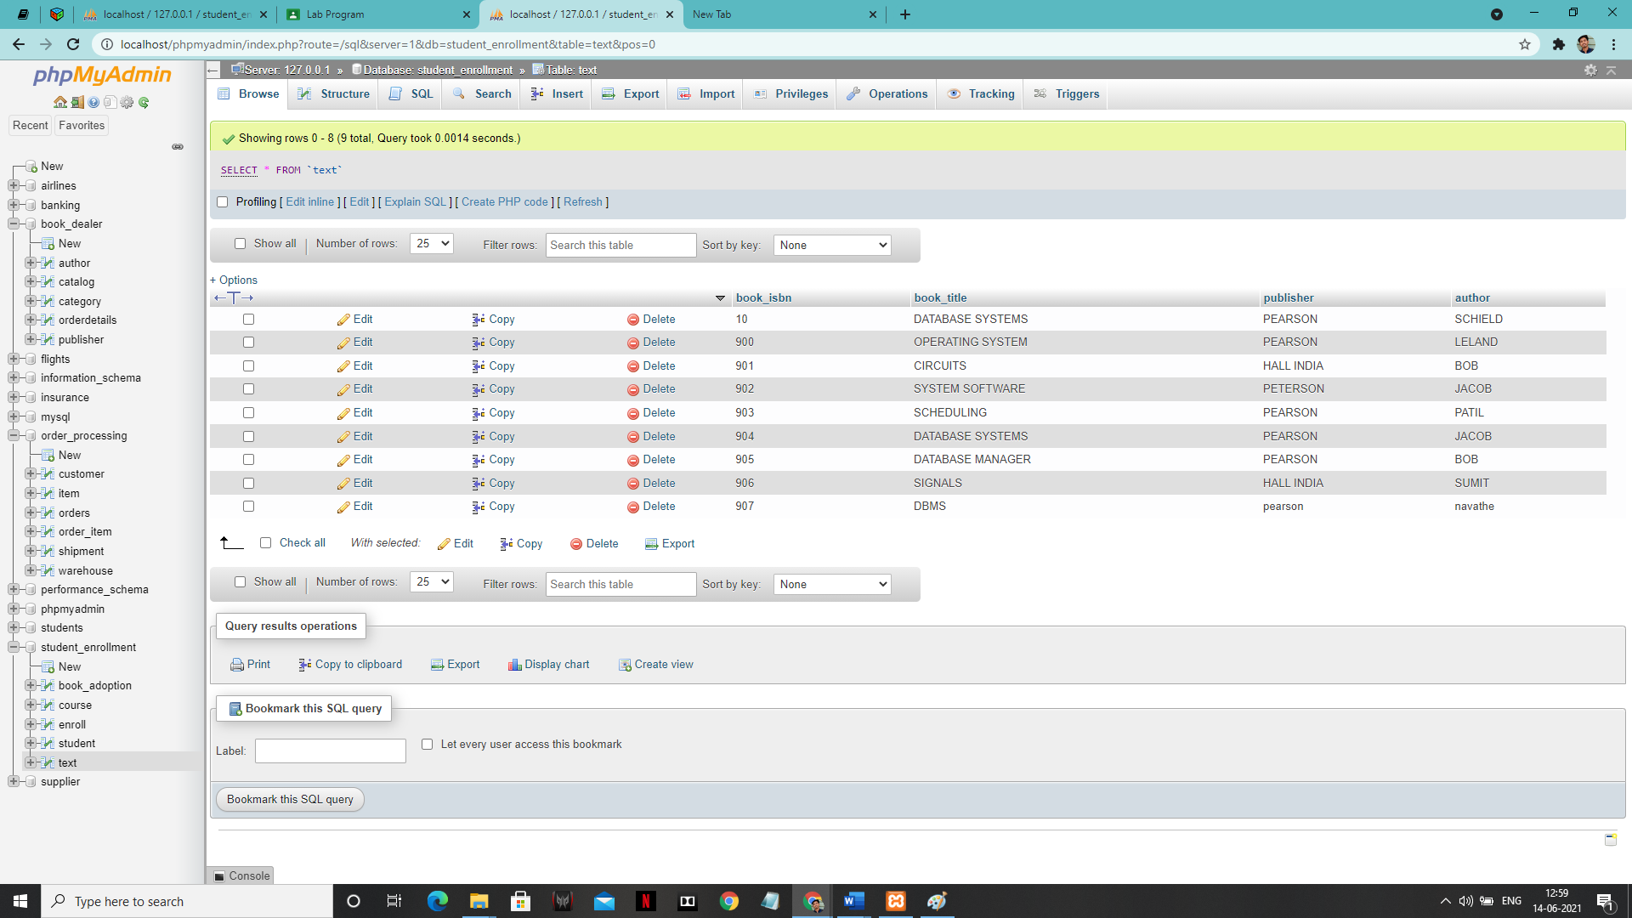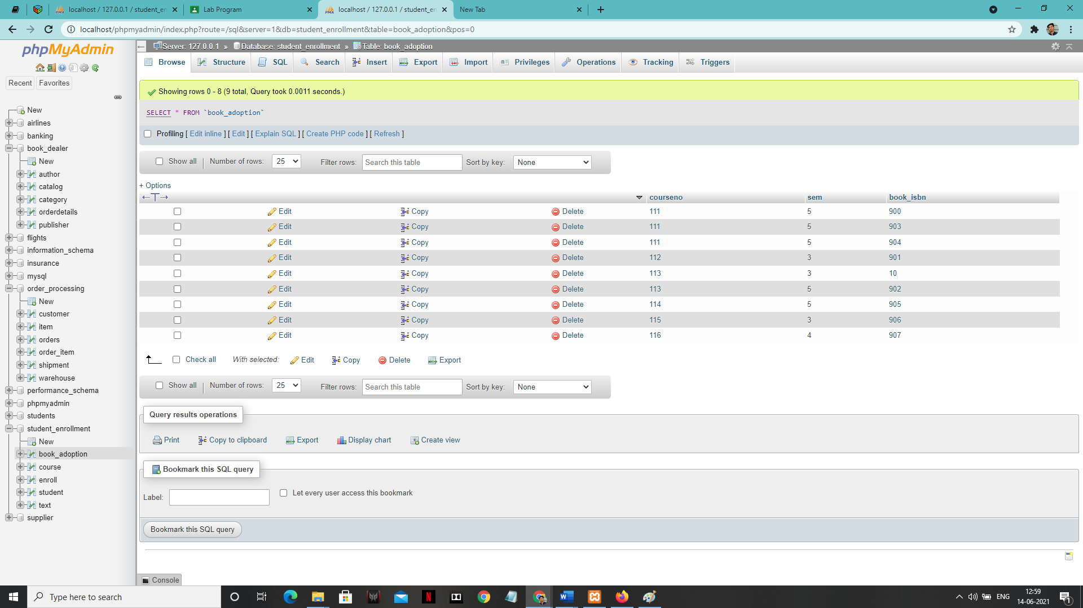

**2:-**

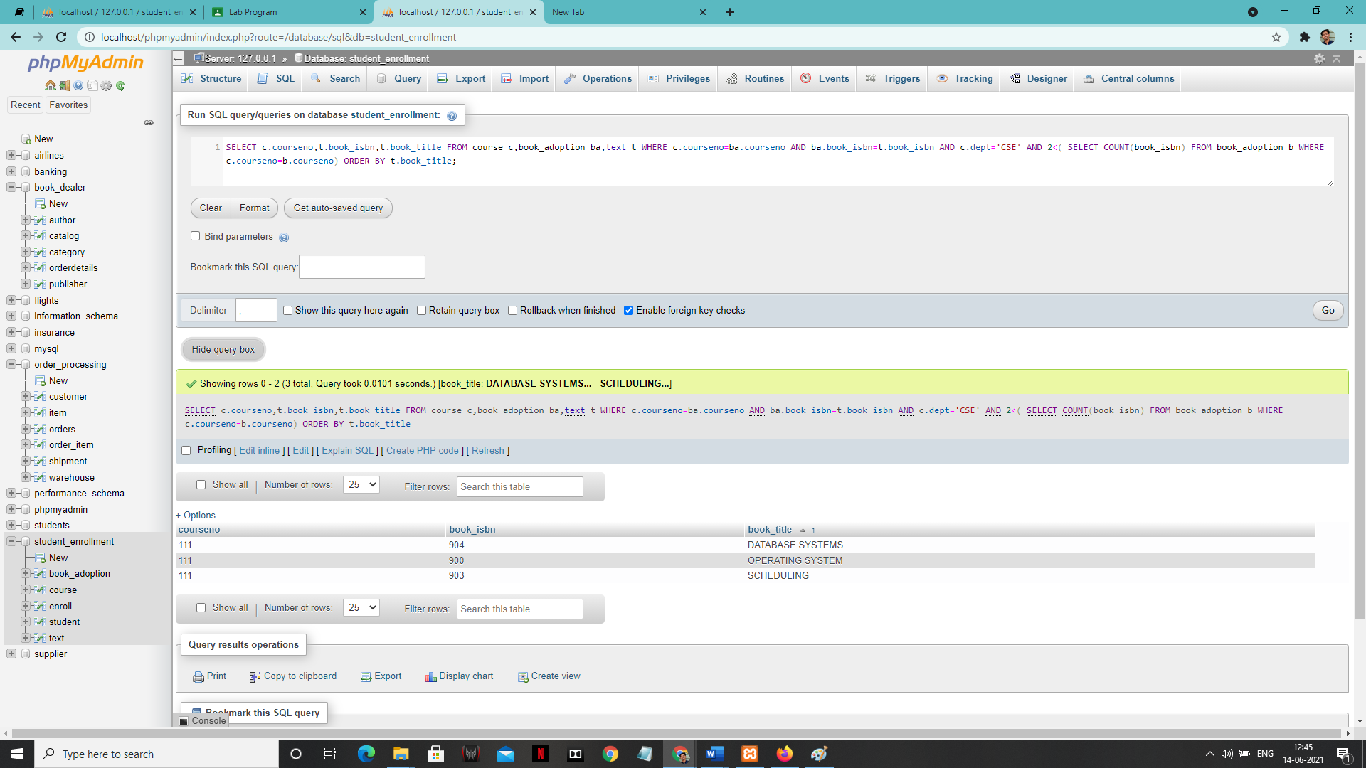

**3:-**

